**PROJECT 1:**

Netbeans existing java.file

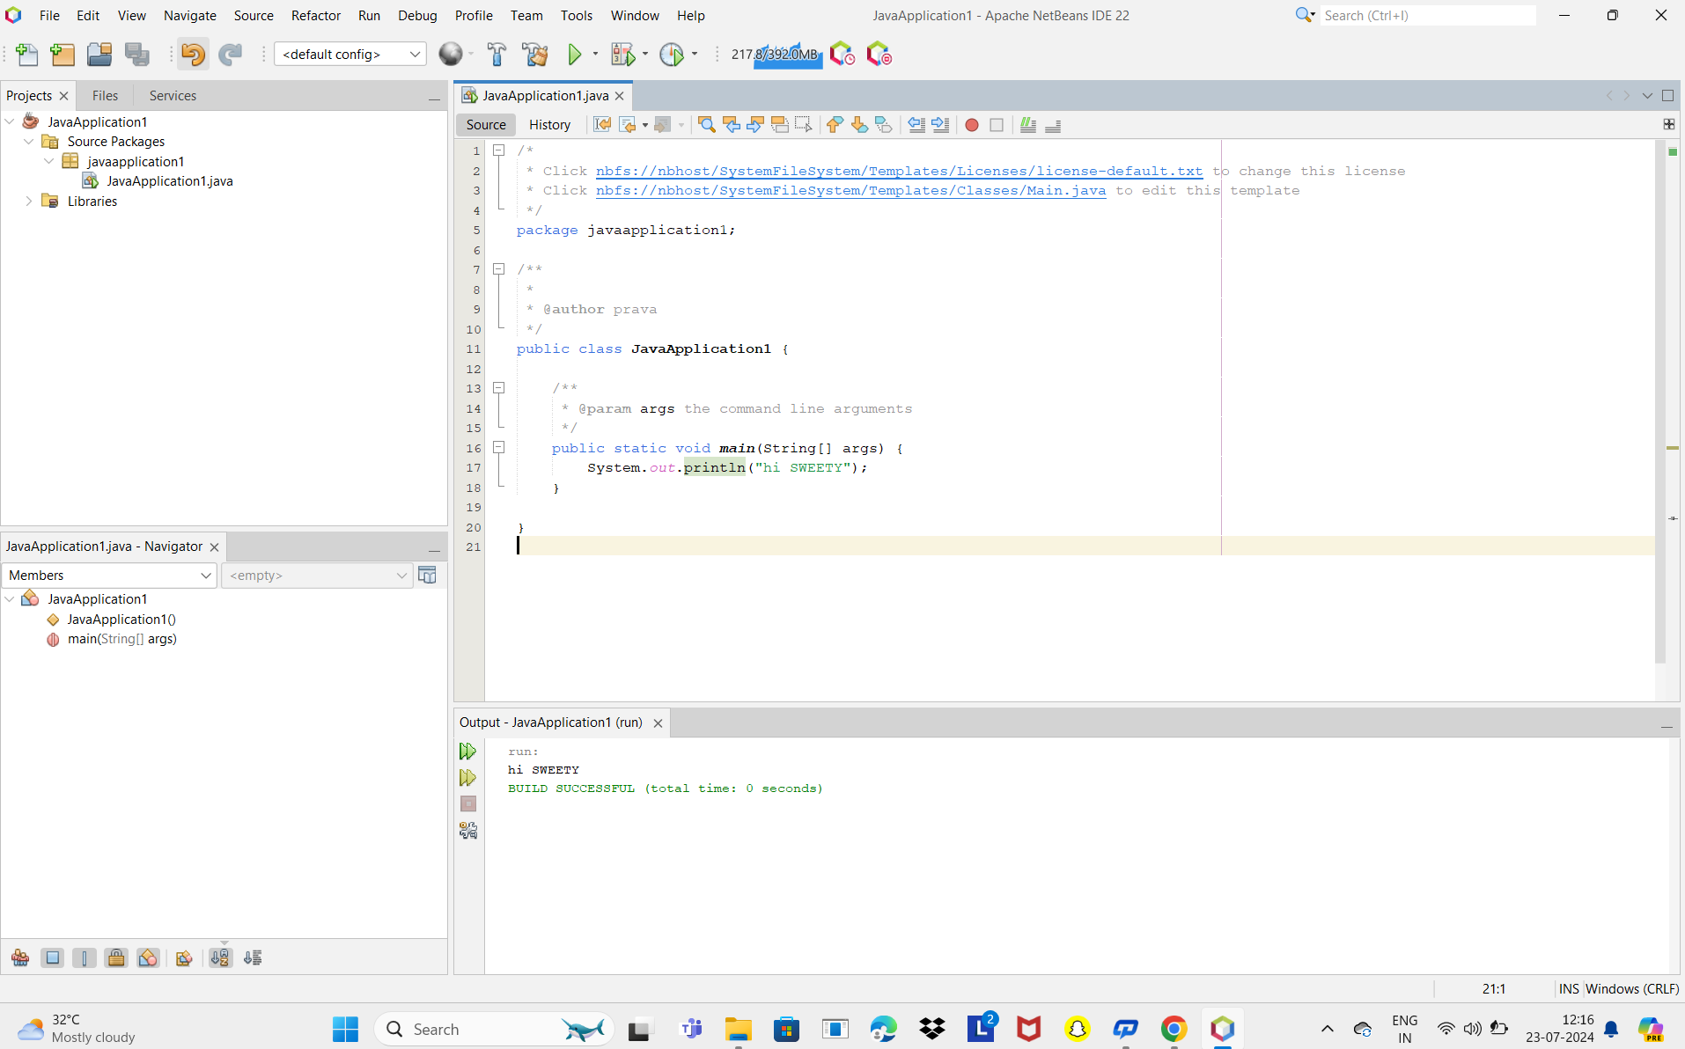

Netbeans new java.file



Eclipse java.file

